|  |  |
| --- | --- |
| Congress House, Great Russell Street, London WC1B 3LS  telephone: 020 7636 4030 fax: 020 7636 0632 [www.tuc.org.uk](http://www.tuc.org.uk/)  General Secretary: *Frances O’Grady* Assistant General Secretary: *Kay Carberry CBE*  Assistant General Secretary: *Paul Nowak* |  |
| Rt Hon Priti Patel MP  Minister of State for Employment  Department of Work and Pensions  Caxton House  Tothill Street London SW1H 9NA | our ref cbi-tuc/FL-ILO  date: 9 December 2015  contact: Owen Tudor  direct line: +44 (20) 7467 1325  email: otudor@tuc.org.uk |

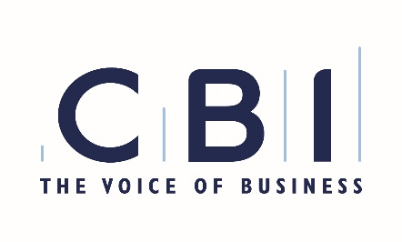Dear Priti

ILO Protocol of 2014 to the Forced Labour Convention, 1930

The CBI and TUC welcomed the passage of the Modern Slavery Act 2015 under the last government. It sent a clear message that forced labour and trafficking will not be tolerated in the UK.

We understand that the then government was committed, as part of this drive to tackle forced labour, to ratifying the ILO Protocol to the 1930 Forced Labour Convention, adopted in 2014, but ran out of Parliamentary time to undertake this process.

We believe that ratification of the Protocol by the UK Government would be a major step forward in ending forced labour around the world, complementing and strengthening existing international law by emphasising prevention and providing access to justice, respecting the rights of victims and ensuring that perpetrators are punished.

In order to maintain momentum in the fight against modern slavery, we would urge that this ratification goes ahead as soon as possible. If there is anything that we can do to help make this happen, do let us know. We would be grateful for an early indication of your thoughts on this matter.

Yours sincerely

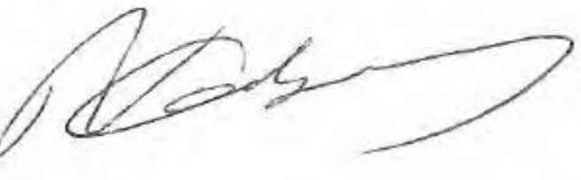

**Neil Carberry**  **Owen Tudor**

Congress House, Great Russell Street, London WC1B 3LS

telephone: 020 7636 4030 fax: 020 7636 0632 [www.tuc.org.uk](http://www.tuc.org.uk/)

General Secretary: *Frances O’Grady* Assistant General Secretary: *Kay Carberry CBE*

Assistant General Secretary: *Paul Nowak*

Director, Employment, Skills & Public Services Head of EU & International Relations

CBI TUC